CS 255 System Design Document Template

This template lays out all the different sections that you need to complete for Project Two. Each section has guidance to prompt your thinking. You will need to continually reference the interview transcript as you work to make sure that you are addressing your client’s needs. There is no required length for the final document. Instead the goal is to complete each section based on what your client’s needs are. Remove this note when you are finished, and replace all bracketed text with the relevant information.

UML Diagrams

UML Use Case Diagram
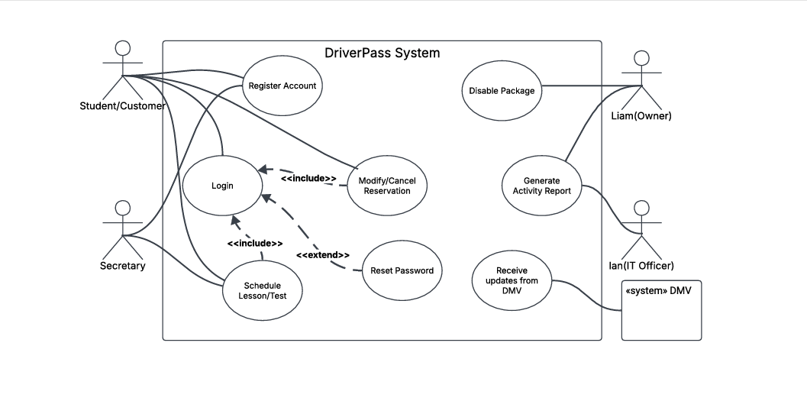

UML Activity Diagrams

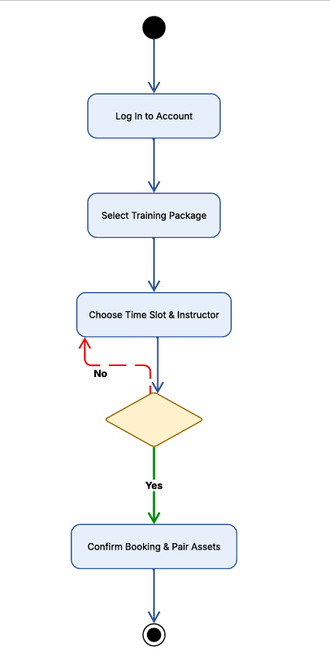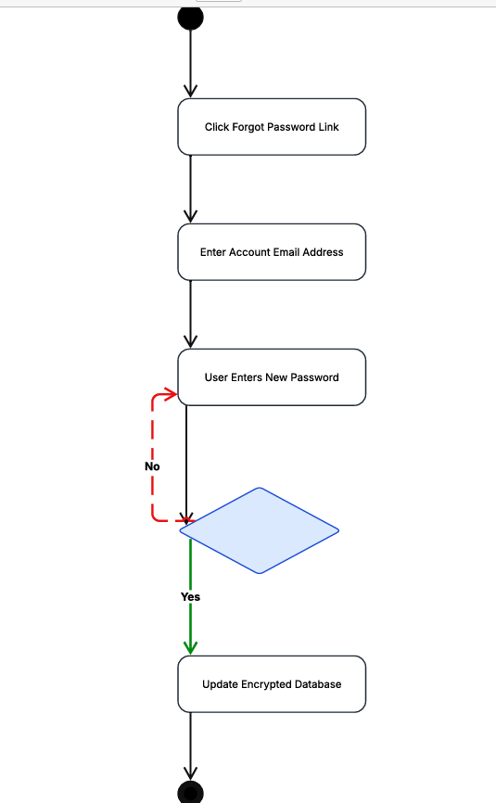

UML Sequence Diagram
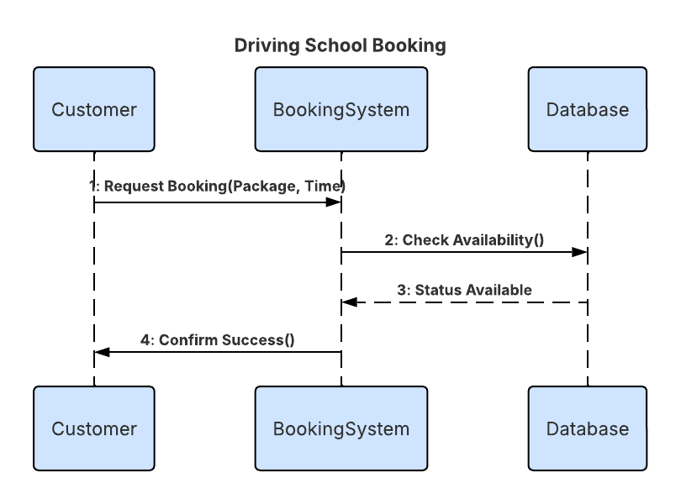

UML Class Diagram
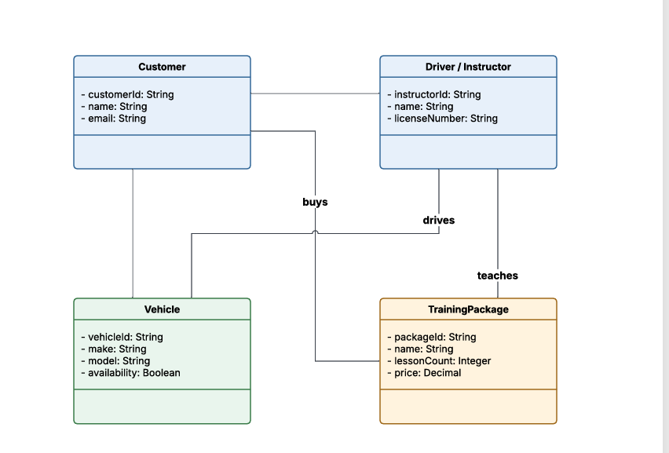

Technical Requirements
The DriverPass website runs entirely online in the cloud, so your business does not need to buy or maintain any expensive physical computer servers. The central cloud server is configured with plenty of processing power and digital memory to handle multiple students booking lessons at the exact same time without lagging. This system connects directly to a secure digital storage vault that holds all of your customer and business records. On the user side, the platform requires no special equipment at all. Students, instructors, and office staff can access every feature using their regular internet-connected smartphones, tablets, or office desktop computers running a standard web browser. The system is designed to automatically resize itself so it looks clean and works perfectly on any screen size.

The system backend is built using a modern programming framework designed to keep different parts of the website organized and running efficiently. It uses a standard, secure database system to track your schedules, car lists, and user accounts. To protect your customers' privacy, all data moving through the website—like logging in or inputting personal details—is protected by secure internet encryption pathways so it can never be stolen or intercepted. The software also includes a background tool that automatically talks to the state DMV website, pulling in instant test and rule updates without slowing down your site. Finally, the system includes a spreadsheet generator tool so management can instantly download clean activity logs straight into Microsoft Excel format.

The cloud setup uses a strict digital gatekeeper system to enforce role-based access rules automatically. This creates a hard wall that stops standard students from viewing private instructor notes or financial data, while giving the manager full control to add or block employees. For safety and emergency planning, the system includes an automated backup service that takes a snapshot of your database every single day. These copies are saved in a separate, highly secure storage bucket in the cloud. If an unexpected computer glitch ever happens, these daily snapshots allow the system to be restored rapidly back to normal, ensuring your business never loses its records.

